# **Alzheimer disease**

**Problem Statement:**

People with Alzheimer's disease first develop subtle memory loss and personality changes that differs from normal age-related memory problems. They seem to tire or become upset or anxious more easily. They do not cope well with change. For example, they can follow familiar routes but traveling to a new place confuses them and they can easily become lost. In the early stages of the illness, people with Alzheimer's disease are particularly susceptible to depression.

As the disease progresses, memory loss worsens and decision making becomes more difficult. A person with Alzheimer’s can become angry when family members try to help. Eventually, social life becomes more difficult, people may not recognize long-time friends or family members, and may become more isolated. In late stages of Alzheimer's people begin to lose physical coordination and may need help with daily functions and taking care of themselves. A person may notice changes in themselves, or changes may first be observed by family members or friends.

Diagnosis of Alzheimer’s typically involves physical and neurological exams, a thorough medical history and mental status evaluation. It may involve brain imaging (such as MRI or CT) which could identify other causes of problems such as stroke, tumor or head trauma.

**Motivation:**

* Recognition of Instrumental Activities of Daily Living (IADL) of patients suffering from Alzheimer DiseaseDecline in IADL is correlated with future dementia

IADL analysis:

Survey for the patient and relatives *--7* subjective answers

* + Observations of IADL with the help of **video cameras** worn by the patient at home .Objective observations of the evolution of disease

**Architechure:**

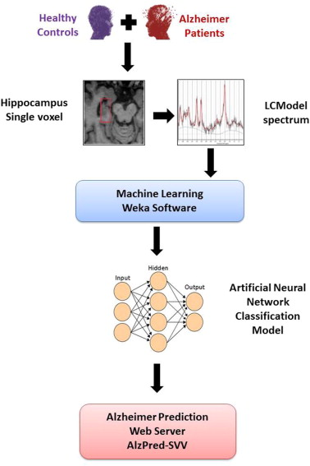

**Validation Statement:-**

In compliance with continuing education requirements, all presenters must disclose any financial or other associations with the manufactures of commercial products, suppliers of commercial services, or commercial supporters as well as any use of unlabeled products or products under investigational use.

CDC, our planners, presenters, and their spouses/partners wish to disclose they have no financial interests or other relationships with the manufacturers of commercial products, supporters. Planners have reviewed content to ensure there is no bias. Presentations will not include any discussion of the unlabeled use of a product or a product under investigational use.

**Tools:**

**WEKA:**

Is a collection of machine learning algorithms for data mining tasks. The algorithms can either be applied directly to a dataset or called from your own Java code. **Weka** contains **tools** for data pre-processing, classification, regression, clustering, association rules, and visualization.

**References**

* 1. Tiraboschi P, Hansen LA, Thal LJ, Corey-Bloom J. The importance of neuritic plaques and tangles to the development and evolution of AD. Neurology. 2004; 62(11):1984–9. Epub 2004/06/09. PMID:

1 [5184601](http://www.ncbi.nlm.nih.gov/pubmed/15184601)

* 1. Blennow K, de Leon MJ, Zetterberg H. Alzheimer’s disease. Lancet (London, England). 2006; 368 (9533):387–403. Epub 2006/08/01.
  2. Harvey PD, Moriarty PJ, Kleinman L, Coyne K, Sadowsky CH, Chen M, et al. The validation of a care- giver assessment of dementia: the Dementia Severity Scale. Alzheimer disease and associated disor- ders. 2005; 19(4):186–94. Epub 2005/12/06. PMID: 1 [6327345](http://www.ncbi.nlm.nih.gov/pubmed/16327345)
  3. Dubois B, Feldman HH, Jacova C, Dekosky ST, Barberger-Gateau P, Cummings J, et al. Research cri- teria for the diagnosis of Alzheimer’s disease: revising the NINCDS-ADRDA criteria. The Lancet Neurol- ogy. 2007; 6(8):734–46. Epub 2007/07/10. doi: 1 [0.1016/S1474-4422(07)70178-3](http://dx.doi.org/10.1016/S1474-4422(07)70178-3) PMID: 1 [7616482](http://www.ncbi.nlm.nih.gov/pubmed/17616482)
  4. Fox NC, Schott JM. Imaging cerebral atrophy: normal ageing to Alzheimer’s disease. Lancet (London, England). 2004; 363(946):392–4. Epub 2004/04/13.Jack CR Jr., Petersen RC, Xu YC, O’Brien PC, Smith GE, Ivnik RJ, et al. Prediction of AD with MRI- based hippocampal volume in mild cognitive impairment. Neurology. 1999; 52(7):1397–403. Epub 1999/05/05. PMID: 1 [0227624](http://www.ncbi.nlm.nih.gov/pubmed/10227624)
  5. Barnes J, Scahill RI, Boyes RG, Frost C, Lewis EB, Rossor CL, et al. Differentiating AD from aging using semiautomated measurement of hippocampal atrophy rates. NeuroImage. 2004; 23(2):574–81. Epub 2004/10/19. doi: [1 0.1016/j.neuroimage.2004.06.028](http://dx.doi.org/10.1016/j.neuroimage.2004.06.028) PMID: 1 [5488407](http://www.ncbi.nlm.nih.gov/pubmed/15488407)
  6. Colliot O, Chetelat G, Chupin M, Desgranges B, Magnin B, Benali H, et al. Discrimination between Alz- heimer disease, mild cognitive impairment, and normal aging by using automated segmentation of the hippocampus. Radiology. 2008; 248(1):194–201. Epub 2008/05/07. doi: [1 0.1148/radiol.2481070876](http://dx.doi.org/10.1148/radiol.2481070876) PMID: [1 8458242](http://www.ncbi.nlm.nih.gov/pubmed/18458242)